Name: Vaibhav Makheja
Business Analyst Project
Project Domain: Travel Booking System
Total Budget: 30,00,000

What is Business Analyst (BA)?
Ans. Business analysis has been defined as "a disciplined approach for introducing change to organization".

- A business analyst (BA) is a person who processes, interprets and documents business processes, products, services and software through analysis of data.

- The role of a business analyst is to ensure business efficiency increases through their knowledge of both IT and business function.

Some tasks of a business analyst include creating detailed business analysis, budgeting and forecasting, business strategizing, planning and monitoring, variance analysis, pricing, reporting and defining business requirements for stakeholders.

Roles of a BA:

A business analyst's job description tends to include "creating detailed business analysis, outlining problems, opportunities and solutions for a business, budgeting and forecasting, planning and monitoring, variance and analysis, pricing, reporting, and defining business requirements and reporting back to stakeholders, More specifically, business analysts are required to use the data which is gathered for the purpose of analysis and interpret greater meaning for the business.

What is Software Development Life Cycle (SDLC)?
Ans. Software development life cycle (SDLC) is a structured process that is used to design, develop, and test good-quality software.

- The goal of the SDLC life cycle model is to deliver high-quality, maintainable software that meets the user’s requirements.
- SDLC is a process followed for software building within a software organization.

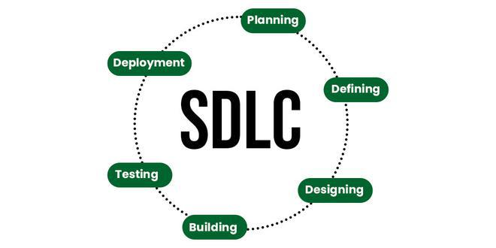
The SDLC model consist of 6 phases while developing any software, they are:

- Planning and Requirement Analysis
- Defining Requirements
- Designing Architecture
- Developing Product
- Product Testing and Integration
- Deployment and Maintenance of Products

Planning and Requirement Analysis: Planning is a crucial step in everything, just as in software development. In this same stage, requirement analysis is also performed by the developers of the organization. This is attained from customer inputs, and sales department/market surveys.

Defining Requirements: In this stage, all the requirements for the target software are specified. These requirements get approval from customers, market analysts, and stakeholders.

Designing Architecture: SRS is a reference for software designers to come up with the best architecture for the software. Hence, with the requirements defined in SRS, multiple designs for the product architecture are present in the Design Document Specification (DDS). This DDS is assessed by market analysts and stakeholders. After evaluating all the possible factors, the most practical and logical design is chosen for development.

Developing Product: At this stage, the fundamental development of the product starts. For this, developers use a specific programming code as per the design in the DDS. Hence, it is important for the coders to follow the protocols set by the association. Conventional programming tools like compilers, interpreters, debuggers, etc. are also put into use at this stage.

Product Testing and Integration: After the development of the product, testing of the software is necessary to ensure its smooth execution. Although, minimal testing is conducted at every stage of SDLC. Therefore, at this stage, all the probable flaws are tracked, fixed, and retested. This ensures that the product confronts the quality requirements of SRS.

Deployment and Maintenance of Products: After detailed testing, the conclusive product is released in phases as per the organization’s strategy. Then it is tested in a real industrial environment. It is important to ensure its smooth performance. If it performs well, the organization sends out the product as a whole. After retrieving beneficial feedback, the company releases it as it is or with auxiliary improvements to make it further helpful for the customers.

What is Agile Sprint?
Ans. The Agile Sprint cycle or workflow, In the Agile development framework, and more especially in approaches like Scrum, is a brief, time-boxed period in which a team works to finish a certain amount of work. Instead of waiting for a whole product to be built, teams can deliver small, incremental amounts of functionality or value through sprints, which are essential to Agile's iterative approach.

Sprint Cycle Explanation: Sprint Cycle (4 Months)

Budget Allocation: 24,00,000 (80% of total Budget)

Role | Percentage distribution | Monthly Salary | 4-Month proportion of Amount | Annual Salary
Frontend Developer | 15% | 90,000 | 3,20,000 | 10,80,000
Backend Developer (2) | 20% | 1,20,000 | 4,80,000 | 14,40,000
UI/UX Designer | 10% | 60,000 | 2,40,000 | 7,20,000
QA Analyst/Tester | 15% | 90,000 | 3,60,000 | 10,80,000
Project Manager | 25% | 1,50,000 | 6,00,000 | 18,00,000
Business Analyst | 15% | 90,000 | 3,60,000 | 10,80,000
Miscellaneous | N/A | 25,000 | 1,00,000 | N/A
Total | 100% | 6,25,000 | 25,00,000 | 72,00,000

Month 1: Initialization of Project Planning and Core Setup

Sprint 1: Planning and Initial Setup
- Initial planning and roadmap of design is created.
- Requirements were gathered from the client.

Sprint 2: Preparation of User module (Software Framework designing)

- Backend Developers begin creating Test Cases
- Frontend developer begins designing UI/UX (User profile management)

Month 2: Development Phase-II Begins

Sprint 3: Creation of Travel Search Filtering

- Search filters were made to narrow down results (by price, category, or duration)
- QA checks the filters after analyzing it and give the necessary feedback on it.

Sprint 4: Ticket Booking System Initialization

- Database was made to store the Travel bookings data (user_id, booking_id, payment status).
- Frontend developer makes booking page form to get user input.

Month 3: Payment Gateway and User Profile

Sprint 5: Payment Gateway Building
- Creating Secure payment infrastructure to handle bookings properly
- Using Proper integration with payment gateways like Billdesk, Razorpay, etc..
- Backend handles payment processing to ensure there is no transaction errors in it.

Sprint 6: User Profile Dashboard
- Creating a user profile dashboard for the user to handle all the bookings, travel itinerary
- Providing features to the user to add, update or delete travel bookings.

Month 4: Testing, Deployment and User Feedback

Sprint 7: Testing and Quality Analysis
- In this phase the final testing is carried out to check whether all the features are working properly or not.

- After QA performs the final testing of the product the software is deployed for feedback.’

Sprint 8: User Acceptance Testing (UAT)
- After deploying the product the User Acceptance Testing is carried out to test whether the software meets all the requirements of the user or not.

- Ensuring smooth operations of the backend servers.

